Day 6 : Advanced Concepts + Comparison (1.5gi Hours)
Learnt
- TestRail vs Xray – deep comparison.
- When TestRail should NOT be used
Situation | Reason
Regulated GxP projects | Weak native traceability
Jira-first organizations | Context switching
Audit-heavy environments | Mutable evidence
Single system mandate | Fragmented tooling

- Why Veeva prefers Xray + Jira
  - Jira is the System of Record
  - Native Requirement Traceability
  - GXP Compliance Support
  - Single Tool, Single Evidence Chain
  - Reduced Validation Effort
Practical
- Mapped:
  - User Story → Test → Execution → Defect
STEP 1: Create / Identify the User Story (Reference)
Since there is no Jira integration, the User Story will be referenced manually.
Example:
- User Story ID: US-101
- Title: User can reset password
You will not create the story inside TestRail.
Instead, you reference it in test cases.

STEP 2: Create Test Cases and Link to User Story
- Go to TestRail → Test Cases
- Open a Test Suite
- Click Add Test Case
- Fill in:
  - Title: Verify password reset with valid email
  - Steps
  - Expected Result
- Link User Story manually:
  - Use References field (or a custom field if available)
  - Example: https://harikakadiyam852.atlassian.net/jira/software/projects/MSSC/boards/2/backlog?selectedIssue=MSSC-5
- Save the test case
STEP 3: Create a Test Run (Execution)
- Go to Test Runs & Results
- Click Add Test Run
- Select:
  - Test Suite
  - Test cases related to US-101
- Name the run: Example: Release 1.0 – Regression
STEP 4: Execute Test Cases
- Open the Test Run
- Click a test case
- Execute and set status:
  - Pass / Fail / Blocked
- Add Execution Comment, for example: Password reset email not received within 5 minutes
STEP 5: Log a Defect and Link It
Since Jira is not integrated, defects are referenced manually.
- Test case status = Failed
- In the execution screen:
  - Find Defects field
- Enter defect ID manually: https://harikakadiyam852.atlassian.net/jira/software/projects/MSSC/boards/2/backlog?selectedIssue=MSSC-12
- Save execution
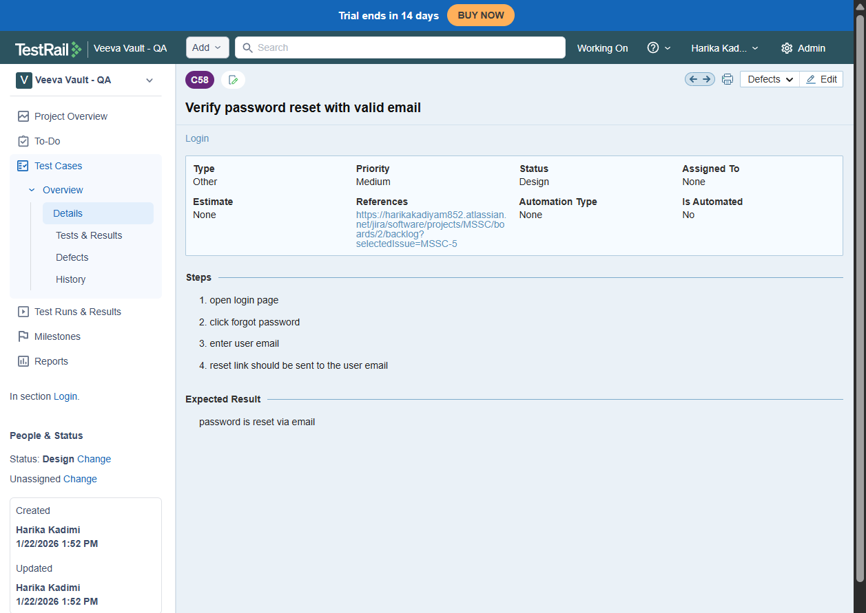

OR
Since TestRail is integrated with Jira
STEP 1: Execute a test in TestRail
- Open your Release 1.0 – Regression run
- Open a test case
- Mark it Failed
- Add execution comment:
STEP 2: Create Jira defect from TestRail (what you just saw)
- Click Add Defect
- Jira “Create Issue” opens
- Fill:
  - Summary
  - Description
  - Priority
- Click Create
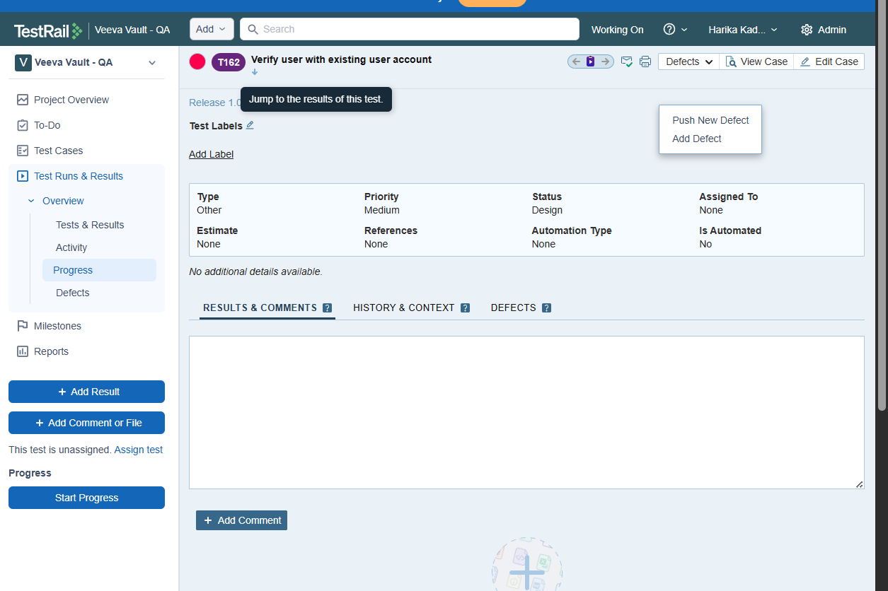
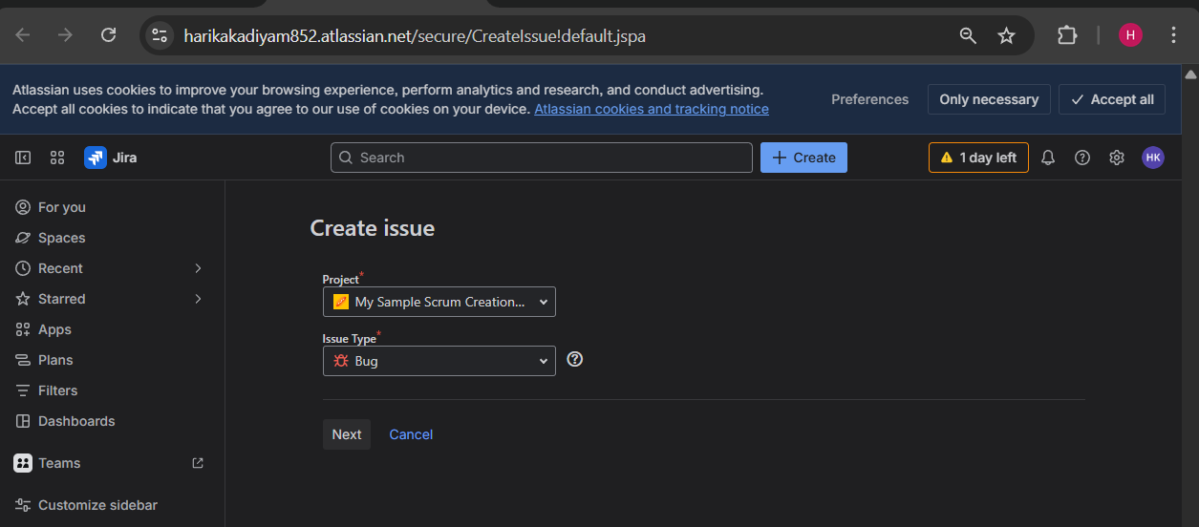
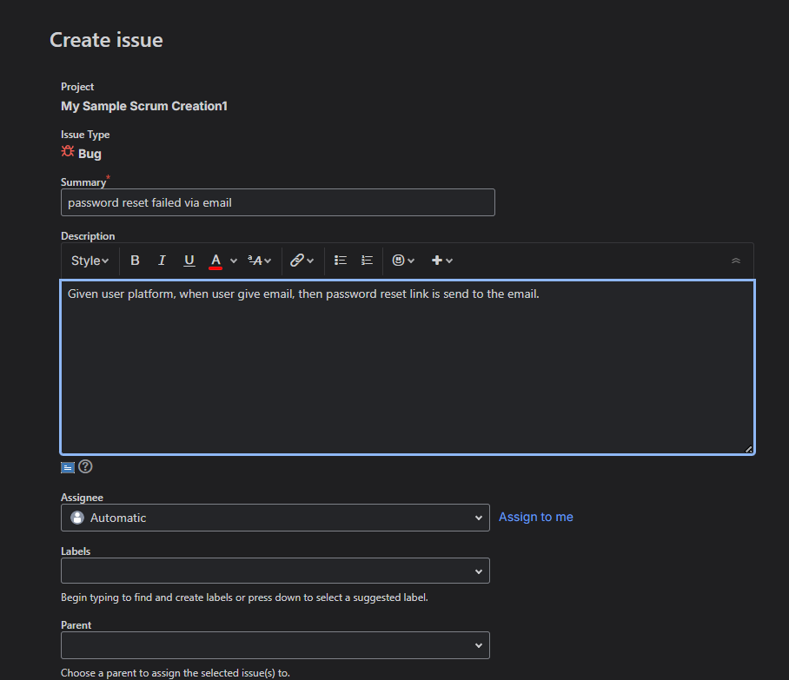
- Identified traceability gaps
Gap 1: User Story without Test Cases
- Jira Story exists
- No TestRail test linked
How to identify:
- Check story → no TestRail references
Gap 2: Test Case without Requirement
- Test exists
- Not linked to any Jira Story
How to identify:
- Test case has no Jira ID in References
Gap 3: Failed Test without Defect
- Test failed
- No Jira bug created
This is now avoidable because you can push defects directly.
Gap 4: Defect without Test Evidence
- Jira bug exists
- Not created from TestRail
- No execution evidence
Common audit finding.

Day 6 : Interview Prep & Final Flow (1.5 Hours)
Practical
- Created full workflow:
  - Test Cases
  - Test Plan
  - Test Run
  - Execution
  - Defect
  - Report
- Prepared answers for:
  - “How do you manage releases in TestRail?”
  - “How do you ensure traceability?”
  - “TestRail vs Xray?”

